Title (Times New Roman 18, bold, centered)

Authors and Adresses (Times New Roman, 14, bold, centered)

INTRODUCTION (Titles, Times New Roman, 12, bold)

Two page abstracts (A4 size – 210 x297 mm) will be submitted in English considering the following instructions:

Title: Times New Roman 16, pt, lower case, bold, centered.

Author(s) and Address(es): Times New Roman 14 pt, bold, centered. The name of the presenting author will be underlined.

Abstract Text: Times New Roman 12 pt – one line spacing – 3 cm margins left/right.

Headers: Times New Roman 12 pt, upper case, bold.

MATERIALS AND METHODS

RESULTS

Pictures, Figures and Tables are allowed in the abstract.

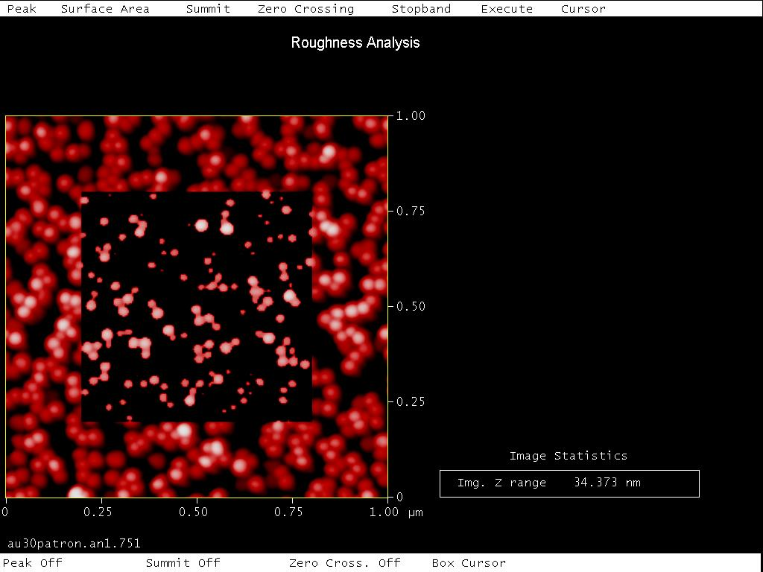
Figure Caption 1: Times New Roman 11, italic

CONCLUSION

REFERENCES

ACKNOWLEDGEMENTS

The limit for submitting the extended abstracts is February 15.

